Power Electronics

Flyback Converter

Taegeon Han & Jaehee Kim, Steel Hard

05/21/23

***Abstract* - This report describes the configuration and operation of the flyback converter circuit. A transformer can be used for the flyback converter to increase or decrease the output voltage. Due to their characteristics such as voltage conversion, energy storage, and operation at a wide range of voltages, flyback converter is used in various applications such as power supplies, and LED drivers. Unlike the ideal theory, the actual flyback converter implementation not only produces different power voltages but also causes power loss because of loss in the switch, transformer core, and parasitic elements. In addition, when the Duty(D) increases highly, there is a problem in that the result value is not measured. While analyzing these problems, think about power loss and consider which factors affect the experimental value. Through this experiment, we can see the difference between theory and practice and think about an appropriate flyback converter design.**

1. INTRODUCTION

T

his report will confirm the configuration of the flyback converter circuit and the operating principles. The flyback converter has a different circuit than the buck-boost converter, but has the same characteristics that can adjust the duty( to increase or decrease the output voltage. However, the flyback converter has the advantage that the inductor is divided into transformers, which multiplies the voltage ratio and insulates the input from the output. The transformer converts or adjusts the voltage by winding ratio, and the flyback converter adjusts the input DC voltage to the desired output DC voltage. The Flyback converter consists of a MOSFET, a transformer, a diode, and a capacitor. It is widely used in a wide range of fields because it is possible to implement simple DC-DC converters with insulated transformers with these few elements. In particular, Flyback converter is widely used in chargers of mobile phones, PC multi-output power supplies, copiers, etc. due to electrical insulation, high efficiency, multiple outputs, and low cost. Through this experiment, we will implement a flyback converter, understand the operating principle, and check the change in output voltage through duty adjustment. We will also compare and analyze the differences by comparing the experimental results with the simulation values.

1. PARTS LIST

|  |  |  |  |
| --- | --- | --- | --- |
| **Parts** | **Specification** | **Value** | **Quantity** |
| Transformer | [750315829](https://lms.handong.edu/courses/12143/files/716060/download?download_frd=1) | - | 1 |
| MOSFET | IRF830 | - | 1 |
| Gate driver | TC1426 | - | 1 |
| PWM generator | TL494 | - | 1 |
| Dual op-amp | TLE207X | - | 1 |
| Diode | FES16DT |  | 1 |
|  | - |  | 1 |
| Inductor | - |  | 1 |
| Capacitor | - |  | 1 |

Table 1. Experimental devices

1. FLYBACK CONVERTER CIRCUIT OPERATION

The Flyback converter is a type of DC-DC converter that supplies voltage. The flyback converter is based on the buck–boost converter. Therefore, the operational principles of the two converters are very similar. Step down or step up are possible, and unlike the Buck-boost converter, the output waveform phase is the same as the waveform of the input. Figure 1 shows the buck-boost converter circuit, and Figure 2 shows the flyback converter circuit with the transformer equivalent circuit model. The magnetizing inductance functions in the same manner as inductor of the original buck–boost converter of Figure 1. When transistor conducts, energy from the dc source is stored in . When diode conducts, this stored energy is transferred to the load, with the inductor voltage and current scaled according to the 1:n turns ratio.

Figure 1. Buck–boost converter circuit

Figure 2. Flyback converter circuit with transformer equivalent circuit model

Several assumptions are required before interpreting the operation of the flyback converter circuit in Figure 2. It is as follows.

1. Steady State Condition
2. Switch is closed for hours and opened for hours
3. Inductor current is continuous
4. Capacitor ≈ ∞ so that is constant
5. All devices are ideal

Basically, the flyback converter step down or step up depending on the switching operation. The circuits depending on the operation of switching are shown below Figure 3 and Figure 4.

During subinterval 1, while transistor conducts, the converter circuit model reduces to Figure 3. flows out of and it flows into the primary side coil of the transformer. The diode connected to the coil on the secondary side of the transformer is OFF state due to the reverse direction current, so that no current flows to the secondary side. The magnetizing inductance , which is parallel to the primary coil, has current and its current is same with . Since flows in the magnetizing inductor circuit, the stores energy.

The inductor voltage , capacitor current , and dc source current are expressed as follows

Figure 3. Flyback converter circuit during subinterval 1

During subinterval 2, the transistor is in the off state, and the diode conducts. The equivalent circuit of Figure 4 is obtained. The primary-side circuit is opened and does not flow. Thus, the current flows from the energy stored in the magnetizing inductor to the transformer to operate the circuit. At this point, the diode is routed to the forward bias and then becomes short, and the diode’s current flows into the capacitor and load resistor. Also, the phase of the output current is reversed.

The primary-side magnetizing inductance voltage , the capacitor current , and the dc source current for this subinterval are

Figure 4. Flyback converter circuit during subinterval 2

Application of the principle of volt-second balance to the primary-side magnetizing inductance shown in Figure 5 yields

Solution for the conversion ratio then leads to

It is similar for Buck-Boost Converter, but differences are the phase and ampere-turns.

Figure 5. Primary-side magnetizing inductance waveform

1. RESULT

This section describes the experimental process. The signal and magnitude of the voltage are measured, and the resulting waveform's values are graphically represented using oscilloscopes and MATLAB. In the lab guidance, the following values are given.

|  |  |  |
| --- | --- | --- |
|  |  |  |
|  |  |  |
|  |  |  |
|  |  |  |

Table 2. Flyback Converter Circuit: Parameter Values

In addition, ∆ ≤ (0.1% × ) and n = 1 should be satisfied.

The Flyback Converter circuit was constructed with these values. And find appropriate values of and C for the design of flyback converter with the above values.

%

Therefore, values are suitable for the design.

We plug in the wall warts that are used to power the electrical components of the protobread. Voltage of the each is powered by the wall wart, and according to the above value, each chip receives a supply voltage of 12 V. The duty value can be adjusted by adjusting the variable resistance of the circuit while receiving a constant supply voltage of 12 V. Also, in Figure 6, is supplied with a voltage of 5 V.

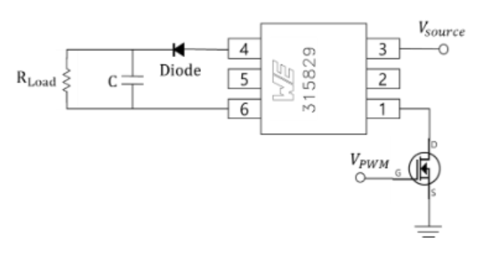

Figure 6. Connection of Flyback Converter with transformer

1. Theoretical values of Flyback converter

The output voltage by Duty() and input voltage ( can be derived using the formula derived earlier.

|  |  |  |
| --- | --- | --- |
| Duty( | Formula |  |
| 0.1 |  |  |
| 0.2 |  |  |
| 0.3 |  |  |
| 0.4 |  |  |
| 0.5 |  |  |
| 0.6 |  |  |
| 0.7 |  |  |
| 0.8 |  |  |
| 0.9 |  |  |

Table 3. Theoretical values of Flyback converter

1. Simulation values of Flyback converter

The flyback converter was created using PSIM as shown in Figure 7. The simulation circuit consists of a circuit that reflects the additional loss elements of the experimental circuit: forward voltage of diode, ESR of Capacitor, and on resistance of MOSFET. The simulation results of the flyback converter according to Duty are shown in Table 4. Each result of this simulation is attached to Appendix.

Figure 7. Simulation flyback converter circuit

|  |  |
| --- | --- |
| Duty( |  |
| 0.1 |  |
| 0.2 |  |
| 0.3 |  |
| 0.4 |  |
| 0.5 |  |
| 0.6 |  |
| 0.7 |  |
| 0.8 |  |
| 0.9 |  |

Table 4. Simulation values of Flyback converter

1. Experimental results of Flyback converter

Now we show the result of output voltage and PWM according to the duty of the flyback converter. This flyback converter is composed of MOSFET, transformer, capacitor, and load resistance. The following figures are the result of a flyback converter.

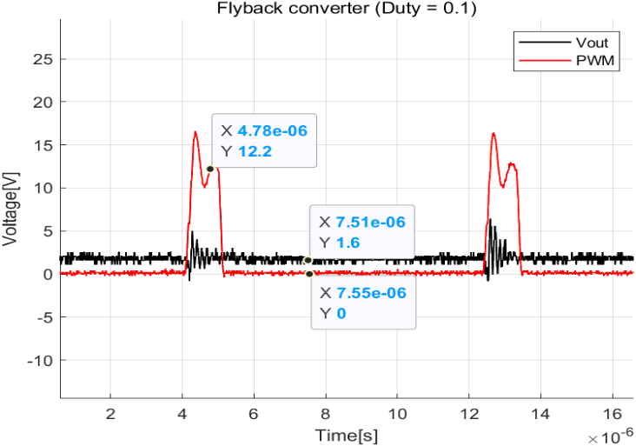

Figure 8. Flyback converter (Duty: 0.1)

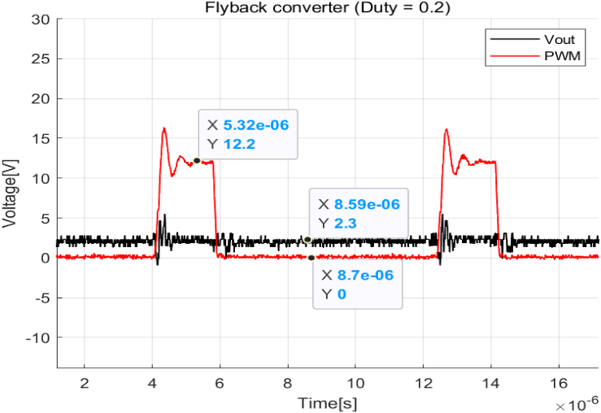

Figure 9. Flyback converter (Duty: 0.2)

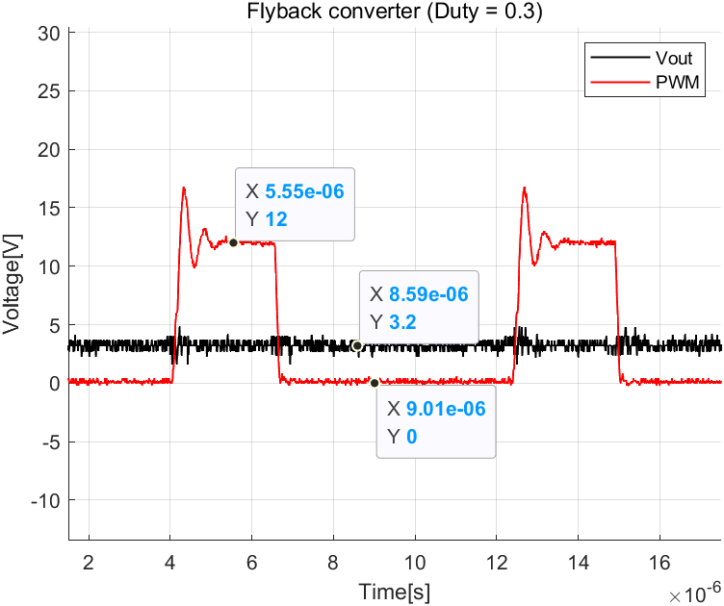

Figure 10. Flyback converter (Duty: 0.3)

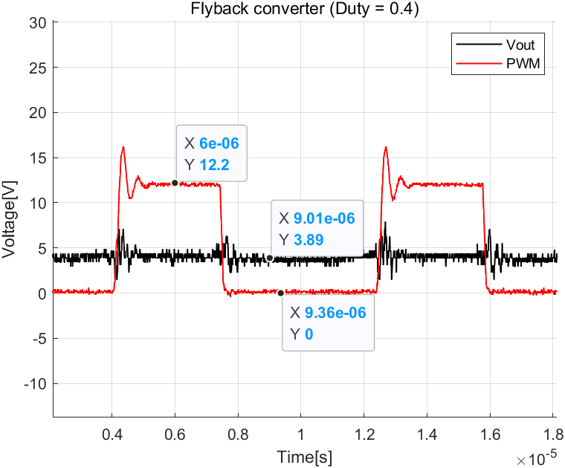

Figure 11. Flyback converter (Duty: 0.4)

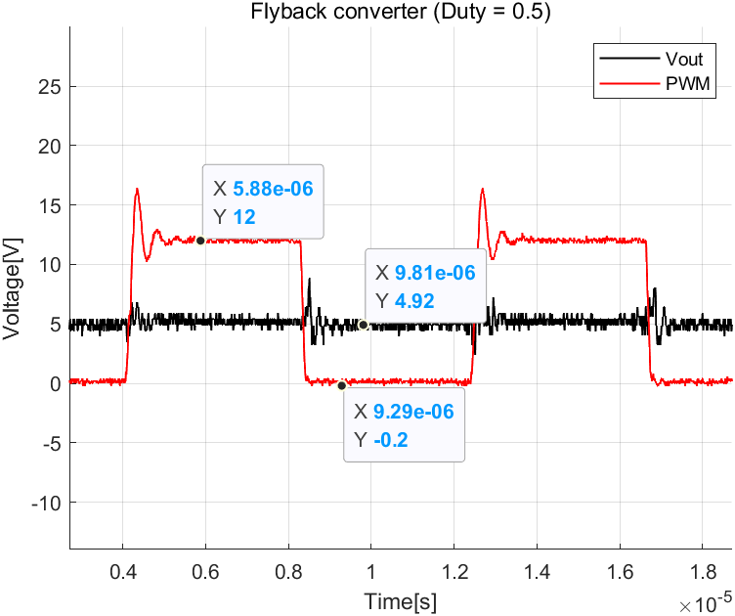

Figure 12. . Flyback converter (Duty: 0.3)

Figure #. Flyback converter (Duty: 0.5)

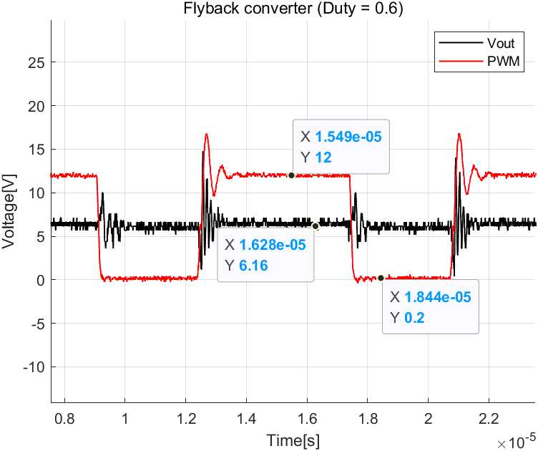

Figure 13. . Flyback converter (Duty: 0.3)

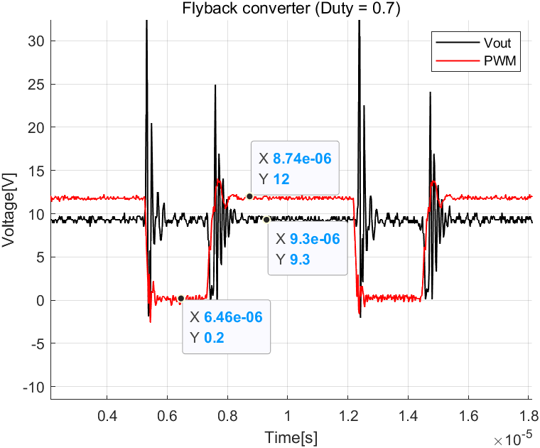

Figure 14. . Flyback converter (Duty: 0.3)

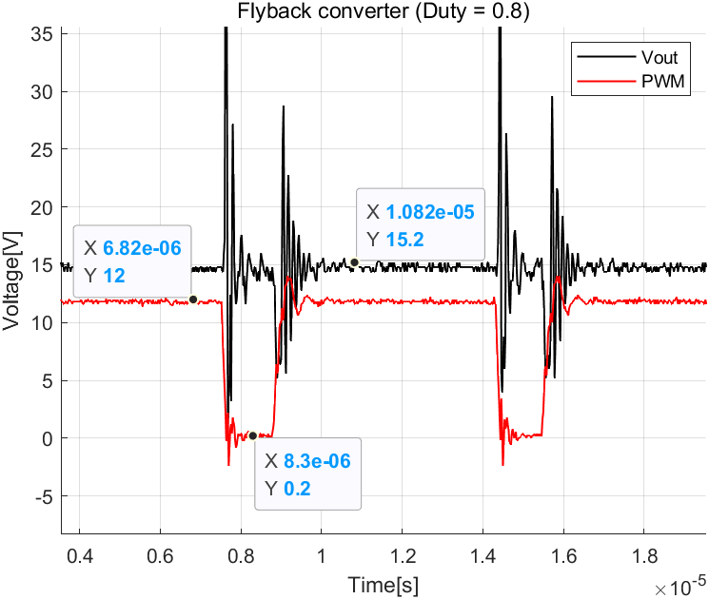

Figure 15. . Flyback converter (Duty: 0.3)

From the measured data, we can get the output voltage of the flyback converter. In addition, as Figure 16 shows, we drew the graph of the experimental, theoretical, and simulation values for the output voltage according to duty using MATLAB.

1. Comparison with A, B, and C of result

Experimental, theoretical, and simulation values for the output voltage of the flyback converter were obtained from the previously calculated or measured data. Table # shows that the output voltage of the flyback converter increases or decreases with duty. Figure 16 is also a comparison graph.

|  |  |  |  |
| --- | --- | --- | --- |
| Duty | Theoretical  value [V] | Simulation  Value [V] | Experimental  Value [V] |
| 0.1 | 0.56 | 0.77 | 1.60 |
| 0.2 | 1.25 | 1.86 | 2.30 |
| 0.3 | 2.14 | 2.99 | 3.20 |
| 0.4 | 3.33 | 4.09 | 3.89 |
| 0.5 | 5 | 5.22 | 4.92 |
| 0.6 | 7.5 | 6.36 | 6.16 |
| 0.7 | 11.67 | 10.10 | 9.30 |
| 0.8 | 20 | 16.46 | 15.20 |
| 0.9 | 45 | 25.58 | - |

Table 5. Comparing the results (output voltage)

Figure 16. Flyback converter voltage output

1. Observation
2. Voltage drop

As a result of the experiment, it can be confirmed that the theoretical value and the experimental value do not match. This is due to a voltage drop. The voltage drop represents the voltage reduction occurring in the components in the circuit. First, the flyback converter uses a transformer element, but the ideal transformer do not have resistance. However, the actual transformer has a transformer winding resistance as shown in Figure #. If a current flows here, a voltage drop occurs due to resistance. The higher the resistance value, the higher the voltage drop.

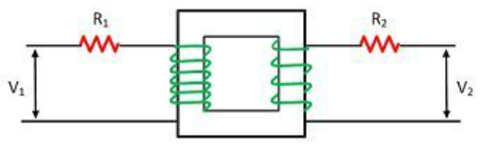

Figure 17. Practical transformer element

Second, the capacitor equivalent series resistance ESR affects the voltage drop. The output capacitor used in the Flyback converter reduces the ripple of the and has an ESR. In ESR, a voltage drop occurs when the output capacitor discharges energy to the load. When the ESR value is high or the capacitance is reduced, the voltage drop increases.

Figure 18. ESR of Capacitor

Third, there is a rectifier diode. A diode is used to rectify the transformer output. When this diode conducts current, a forward voltage drop occurs. This forward voltage drop is generally small, but it can contribute to the overall voltage drop.

Figure 19. Forward Voltage on Diode

Finally, there is a resistance ((on)) between the drain and the source. MOSFET is used as a switch in the flyback converter, and a small voltage drop occurs when it is turned on. Increasing the voltage of the gate or lowering the voltage between drain and source reduces the (on) value, which also reduces the voltage drop. As shown in Figure #, the (on) of the mosfet used in this experiment has a maximum value of 1.5[Ω].

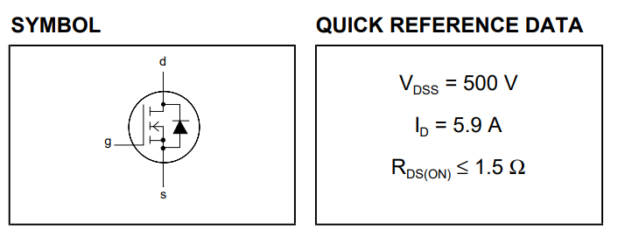

**Figure 20. MOSFET specification**

|  |  |  |  |
| --- | --- | --- | --- |
| Duty | Experimental voltage [V] | Theoretical voltage [V] | Error [%] |
| 0.1 | 0.56 | 1.6 | -185.7 |
| 0.2 | 1.25 | 2.3 | -84 |
| 0.3 | 2.14 | 3.2 | -49.53 |
| 0.4 | 3.33 | 3.89 | -16.82 |
| 0.5 | 5 | 4.92 | 1.6 |
| 0.6 | 7.5 | 6.16 | 17.87 |
| 0.7 | 11.67 | 9.3 | 20.31 |
| 0.8 | 20 | 15.2 | 24 |

Table 6. Output voltage of flyback converter

As can be seen in Table #, the experimental value was larger than the theoretical value when the Duty was 0.5 or less. When Duty exceeds 0.5, it can be confirmed that the experimental value is smaller than the theoretical value. According to the duty, the effect on the output voltage varies for various reasons, such as the voltage drop described above, so the output voltage also varies.

1. Using the transformer

In this experiment, the output power value was derived using a transformer in the flyback converter. The transformer has two coils wound around the core. The side where the voltage is input is called primary, and the side where the output voltage is output is called secondary. First, when a voltage is applied to the primary coil, a magnetic field is generated, which is transmitted to the core and transmitted to the secondary coil. When switched on state, energy is transmitted and stored in the transformer's magnetic field. On the other hand, when switched off state, the stored energy is released to the output side. The Ampere and Faraday laws are used in this process. In an ideal transformer, the power of both coils is constant. That is, power is transferred from the primary coil to the secondary coil as it is. However, in the practical model, loss occurs due to transformer winding resistance in the process of delivery, reducing the power of the secondary coil, and causing a voltage drop as described in observation A. In contrast, there are also advantages of transformer. The turns ratio between the primary and secondary windings determines the output voltage. Therefore, the flyback transformer is capable of accurate voltage adjustment, so it can output a stable output voltage despite changes in input voltage. In addition, energy can be stored in the magnetic field to efficiently transfer energy to the load when the switch is off. For these reasons, transformers are used in flyback converters.

The Transformer of the Flyback converter has the following characteristics. Referring to Figure #, the following equation is given.

So, if you wind the secondary coil more, the voltage increases but the current decreases. Conversely, if the coil is wound less, the voltage decreases but the current flows more. As the polarity of the transformer is determined by the winding direction. In the Figure #, when the coil is wound in reverse, when the input is +, the output becomes -. Therefore, the following equation is given.

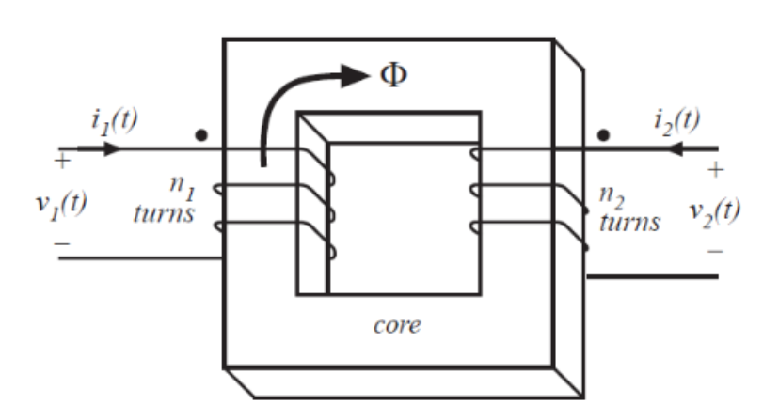

Figure 21. Transformer

1. High Duty unmeasurable

The duty value was adjusted by adjusting the variable resistance to check the output voltage according to the duty. Meanwhile, the Duty could be measured up to 0.8, but after that, it could not be measured. In the Flyback converter experiment, if the Duty is high, the switch remains on for a longer time than the off state, which may affect the MOSFET used as a switch. As the duty is large, the MOSFET consumes more time in a conductive state, so the high voltage drop may occur, and the high voltage drop may cause a high power loss within the MOSFET. High power loss increases heat generation of MOSFET, which may affect performance. Additionally, MOSFET have a rated voltage which indicates the maximum voltage they can handle without experiencing damage. If the duty is high, the voltage at both ends of the MOSFET exceeds the rated voltage, and thus resistance may increase, overheating may occur, and a device may be destroyed. Therefore, it is important not to exceed the rated voltage of the MOSFET. To this end, a MOSFET with a higher rated voltage can be used or cooling measures such as a heat sink can be implemented for heat dissipation.

# CONCLUSION

In this experiment, the flyback converter circuit was implemented and the operating principle was analyzed. The power voltage was adjusted by adjusting the Duty value using the variable resistance in the circuit under the conditions given by LAB guidance, and the power voltage was stably derived using the Capacitor and inductor. It was also confirmed that the output voltage can be adjusted through the transformer's winding ratio. The flyback converter has a different experimental value and a different theoretical value because of a voltage drop caused by transformer winding resistance, ESR of capacitor, forward voltage of diode, etc., and a loss occurred in this process. The Flyback converter has the advantage of increasing or decreasing the voltage, but the higher the Duty, the higher the voltage of the MOSFET, causing problems that cannot be measured. Therefore, when designing a flyback converter, it is necessary to implement a circuit by selecting an appropriate MOSFET.

# WORK DISTRIBUTION

|  |  |  |
| --- | --- | --- |
|  | Kim, Jaehee | Han, Taegeon |
| Circuit construction | 50% | 50% |
| Circuit Testing | 50% | 50% |
| Report | 50% | 50% |

# PROBLEMS

**Problem 1)**

In a Flyback converter shown in Fig. 1, and the magnetizing inductance This converter is operating in equivalent CCM with a switching frequency and supplying an output load Assuming this converter to be lossless, calculate the input and output waveforms

**Problem 2)**

In Problems 2, consider a Flyback converter with turns, and turns. The self-inductance of winding at 1 is . The output voltage is regulated at

Calculate and draw the waveforms of inductor current, input current, output current and the ripple current in the output capacitor, if the load is 30 W.

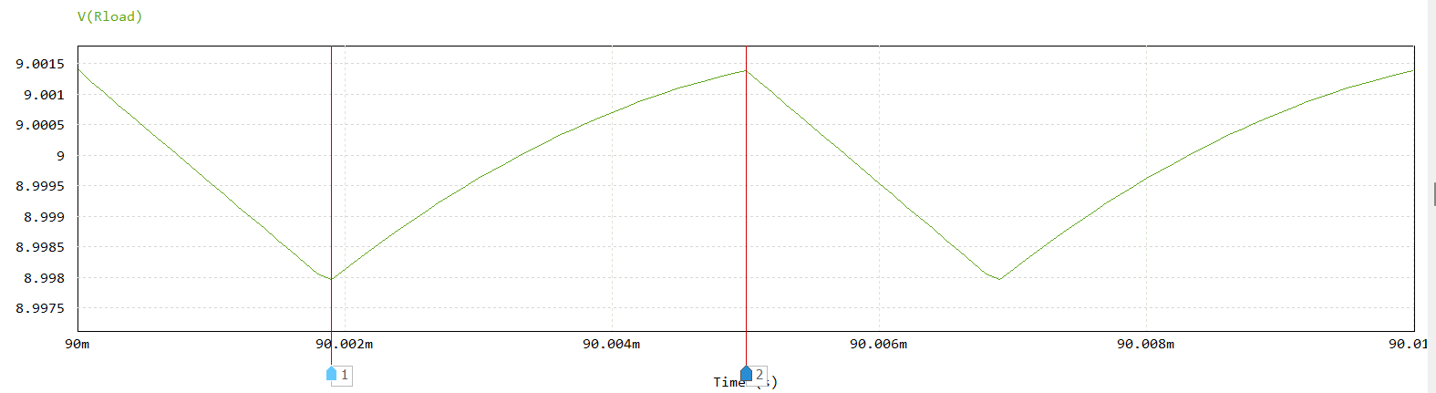

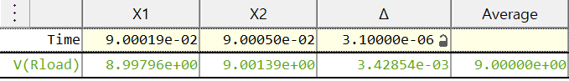

**Figure 21. Simulation waveform of output voltage**

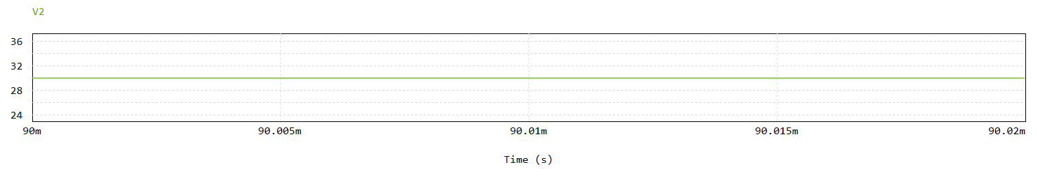



**Figure 22. Simulation waveform of input voltage**

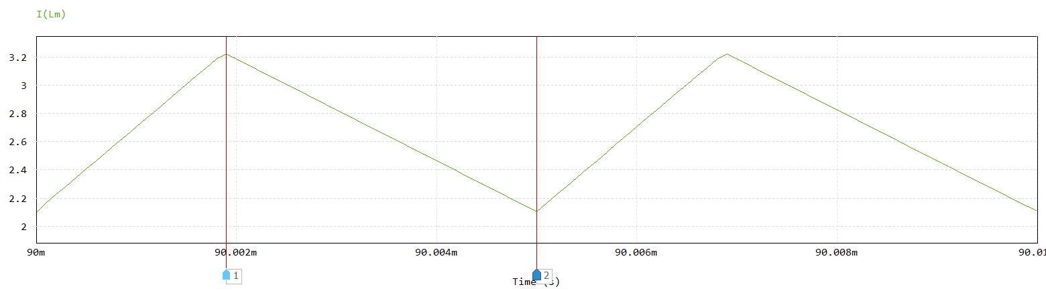 

**Figure 23. Simulation waveform of**

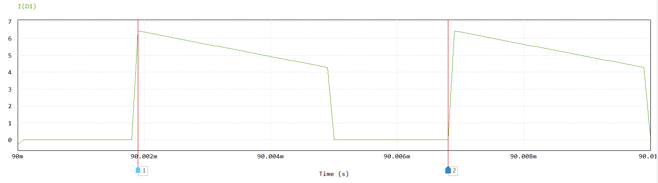



**Figure 24. Simulation waveform of Diode current**

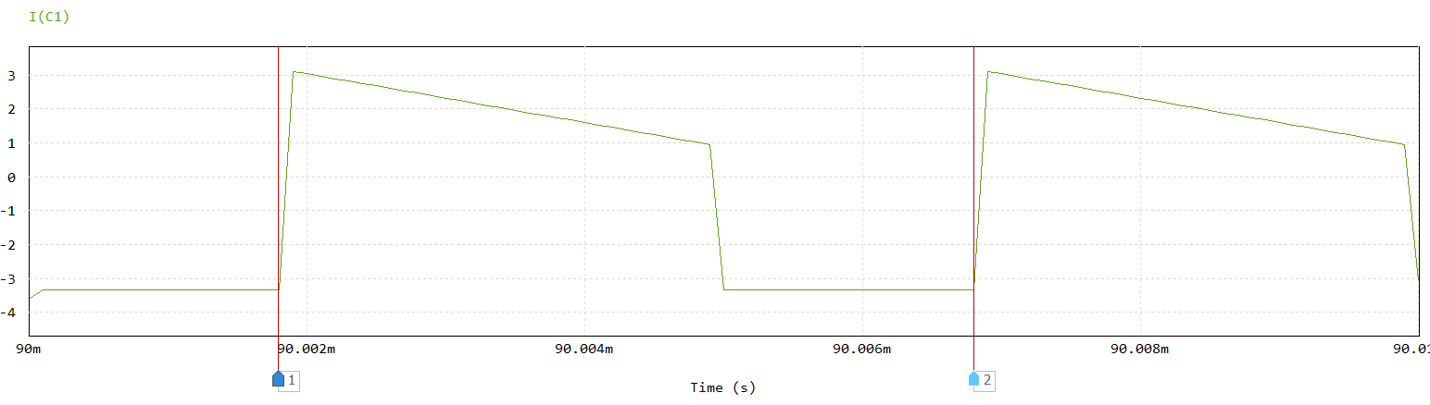

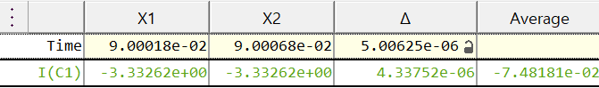

**Figure 25. Simulation waveform of Capacitor current**

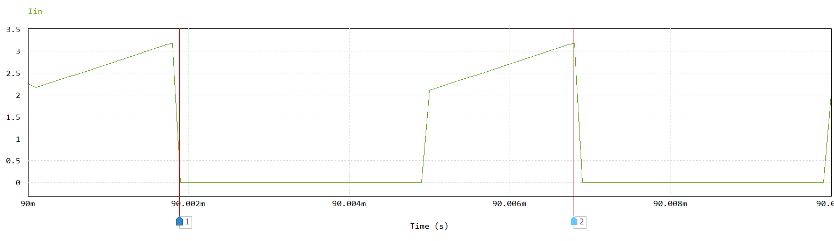 

**Figure 26. Simulation waveform of input current**

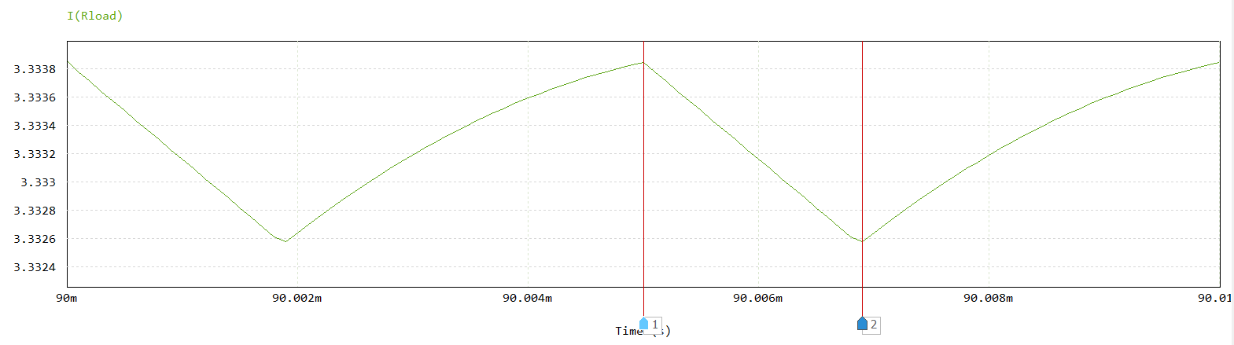

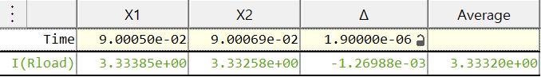

**Figure 27. Simulation waveform of output current**

# APPENDIX

Figure 28. Flyback converter circuit

Figure 229. Simulation result (Duty: 0.1)

Figure 3023. Simulation result (Duty: 0.2)

Figure 24. Simulation result (Duty: 0.3)

Figure 252. Simulation result (Duty: 0.4)

Figure 33. Simulation result (Duty: 0.5)

Figure 34. Simulation result (Duty: 0.6)

Figure 35. Simulation result (Duty: 0.7)

Figure 36. Simulation result (Duty: 0.8)

Figure 37. Simulation result (Duty: 0.9)



Figure 38. MATLAB code of result graphs

Figure 39. MATLAB code of Figure 16 graphs